USER MANUAL
INTELLIMA

Table of Contents
- Authentication & Authorization
- Users Overview
- Seller Functions
- Buyer Functions
- Bank Functions
- Breeder Functions
- Inventory Manager Functions
- Slaughter House Manager Functions
- Chilled Warehouse Functions
- Collateral Manager Functions
- Export Manager Functions

Authentication & Authorization

Users:
- Sellers
- Buyers
- Breeders
- Bank
- Slaughter House Manager
- Collateral Manager
- Inventory Manager
- Export Manager

Seller Functions

Registration and Login
- System Administrator registers the Seller and Bank.
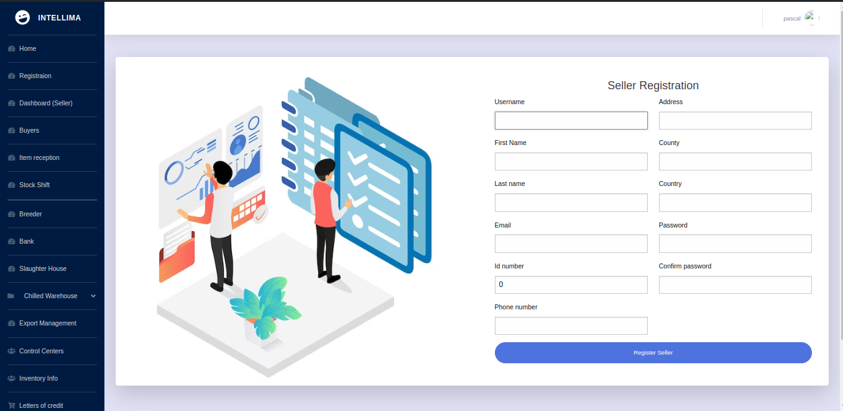
- Seller receives an email to set their password.
- Upon successful password setup, the Seller can log in to the system.

Dashboard Overview
- Supply and Demand Statistics: Sellers can view these for decision-making.
- Letters of Credit and Quotations: Both approved and rejected.
- Item Supply History: Detailed records of past supplies.
- Inventory Items: View items with cumulative totals.
- Weight Comparison: Track item/breed tag numbers throughout the supply chain and compare weights.

Buyer Management
- Seller registers the Buyer.
- Buyer receives an email to set their password and logs in.
- Seller sends a quotation to the Buyer based on prior agreements.
- PDF documents for both Buyer and Seller are auto-generated.
- Buyer receives an email with the new quotation and PDF.
- Buyer can accept or reject the quotation:
  - If rejected, they must provide a reason.
  - If accepted, the Buyer communicates with their bank to send a Letter of Credit (LC) to the Seller's bank.

Letter of Credit (LC) Management
- Bank sets their password upon registration and logs in.
- Bank uploads the PDF received from the Buyer’s bank.
- The PDF should contain:
  - Clause 93A: Item description
  - Clause 93B: Weight in kilograms
  - Clause 93C: Delivery date
- Seller accepts or rejects the LC:
  - If rejected, a reason must be provided.
  - If accepted, the system converts weight to quantity and broadcasts the requirement to registered breeders.

Buyer Functions

Quotation Management
- Receives email notification for new quotations.
- Reviews and accepts or rejects the quotation:
  - If accepted, coordinates with their bank for LC issuance.
  - If rejected, provides a reason.

Bank Functions

LC and Payment Management
- Uploads LCs received from the Buyer’s bank.
- Views Bill of Lading documents during exports.
- Monitors LC statuses and payment confirmations from Inventory Managers.
- Processes payments based on confirmation statuses.

Breeder Functions

Supply Management
- Logs in to view required quantities.
- Fills in the supply form based on capacity.
- Tracks supply history and status changes.

Inventory Manager Functions

Supply Confirmation
- Logs in to view unconfirmed supplies.
- Confirms received items.
- Tracks item statuses and payment processing.

Slaughter House Manager Functions

Item Management
- Logs in to record item weights pre-slaughter.
- Fills in forms to deduct inventory items.
- Records export and local sale parts.

Chilled Warehouse Functions

Inventory Tracking
- Records items based on slaughterhouse manager's input.
- Separates items into export and local sale categories.

Collateral Manager Functions

Inventory Oversight
- Registered by the bank.
- Oversees inventory information for assigned control centers.

Export Manager Functions

Export Documentation
- Fills in export details from Seller to Buyer.
- Tracks export status.
- Generates necessary documents like invoices and packaging information.

